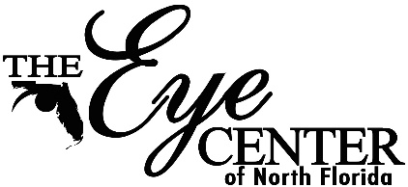

Donation Application

We take pride in serving our patients and the community. We do receive a large amount of requests and all donations are based off of our annual budget. For consideration for next year, please have all donation requests in by November 1st of the current year.
Please fill out all of the information below and submit to community@eyecarenow.com with any additional paperwork or information you may have.

Date of Request: _______________________________________________________________
Organization: __________________________________________________________________
Contact Person: ________________________________________________________________
Phone: _______________________________________________________________________
Address: ______________________________________________________________________
Email: ________________________________________________________________________
Is your organization a 501c3, or not for profit? Yes ___ No ___
Is there an event associated with your request? Yes ___ No ___
If yes, Date of Event: ______________ Time: ______________
Location: ______________________________________________________________________
Event description: __________________________________________________________________________________________________________________________________________________________________________________________________________________________________________
Is your request for a Monetary donation ____ Auction/Raffle item ____ Both ____
Monetary Amount requested: ____________________

